Thousand Hills Lifetime Grazed 2023 Regenerative Ag Beef Affidavit
Ear Tag # | Ear Tag Color | Sex (S/H) | Age (months) | Breed | Hide Color
Ear Tag # | Ear Tag Color | Sex (S/H) | Age (months) | Breed | Hide Color
Ear Tag # | Ear Tag Color | Sex (S/H) | Age (months) | Breed | Hide Color

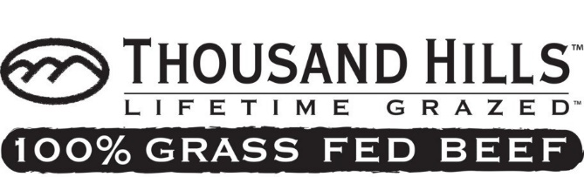
I, , certify that the beef cattle I am selling to Thousand Hills Lifetime Grazed have been raised according the Producer Protocol posted on thousandhillslifetimegrazed.com and the American Grassfed Association standards posted on americangrassfed.org. In brief summary:
- These cattle have never been given any antibiotics, whether sub-therapeutic (mixed with feed), or therapeutic (intramuscular or IV shots).
- These cattle have never been given any sort of artificial hormone, steroid, or growth enhancers, or fed any animal by-products (bone meal, hog fat, etc).
Seller Information: Please Print  Name | Seller Information: Please Print  Name
Address | Address
City | City
State Zip | State Zip
Phone | Phone
Email | Email
Price Quoted for HCW: | Price Quoted for HCW:

- These cattle have not been fed GMOs, genetically-engineered plants, soy hulls, grain products, DDGs or mature corn silage, at any point in their lives.
- These cattle have been raised on synthetic pesticide/herbicide free pasture during the growing and non-growing season, and fed only approved forages during the dormant season.
- Carcasses that fail to meet any of the following criteria will be discounted $0.40/lb. HCW from quoted price.
  - Grade of Select 30 or higher per the processor’s assessment
  - Minimum ribeye area of 9.6 square inches, per the processor’s assessment.
  - Maximum carcass weight of 799 lbs.
- Cattle that are delivered without the TH affidavit properly completed will be discounted $20 per head.
- These cattle were born and raised in the USA.
Signed and sworn on this day of 2023 By:
Producer
MAIL:12925 Prosperity Ave. • Becker, MN 55308 or SCAN & EMAIL to:acarney@lifetimegrazed.com

